Compute the Black Body Calibration parameters for Hurley IR camera by Tze-Yuan Cheng 2014/02/10

1. In MATLAB, open the main file: “BlackBody_calibration_data_assembly”

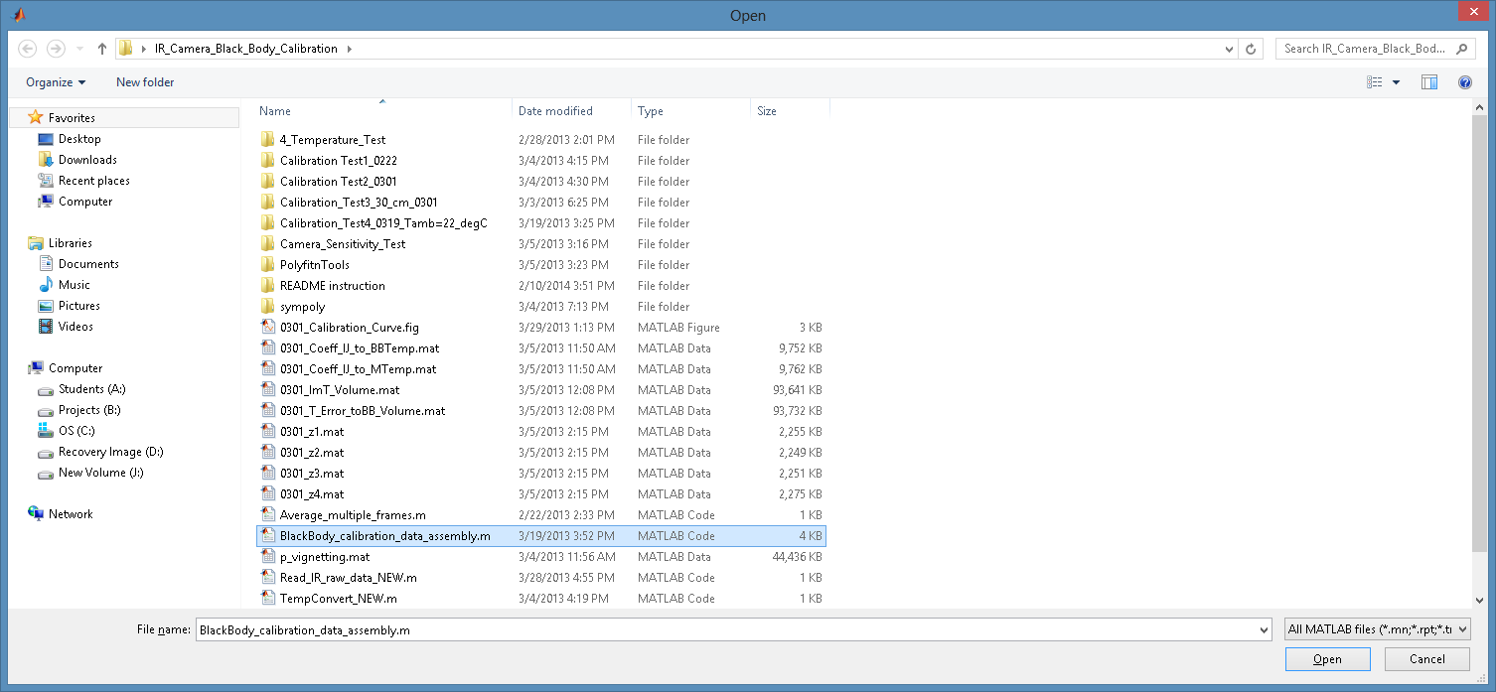

1. In the environment setting, choose “Set Path”🡪 “add with subfolders”, and choose the black body image folder , for example: \IR_Camera_Black_Body_Calibration\Calibration Test2_0301

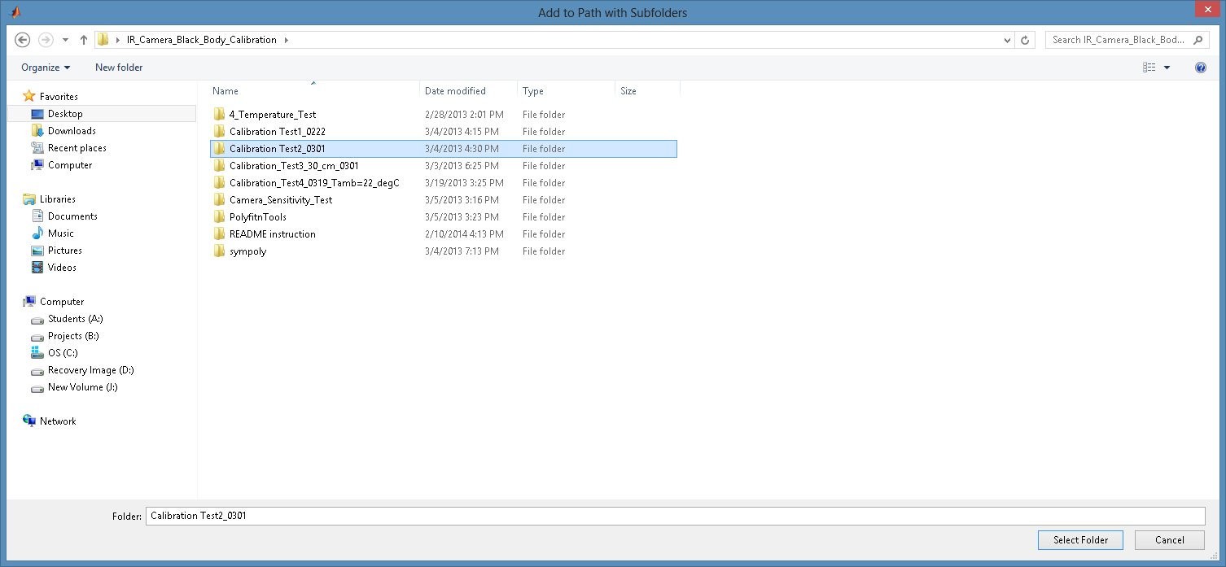

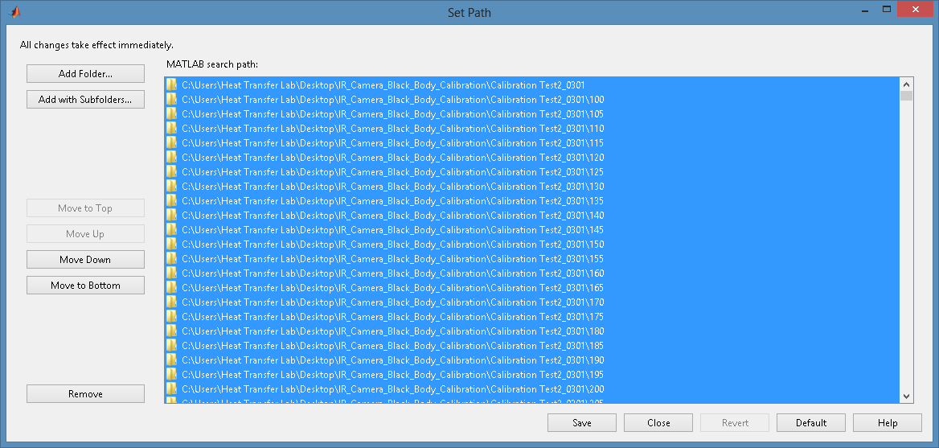

1. Once the folders are selected, press F5

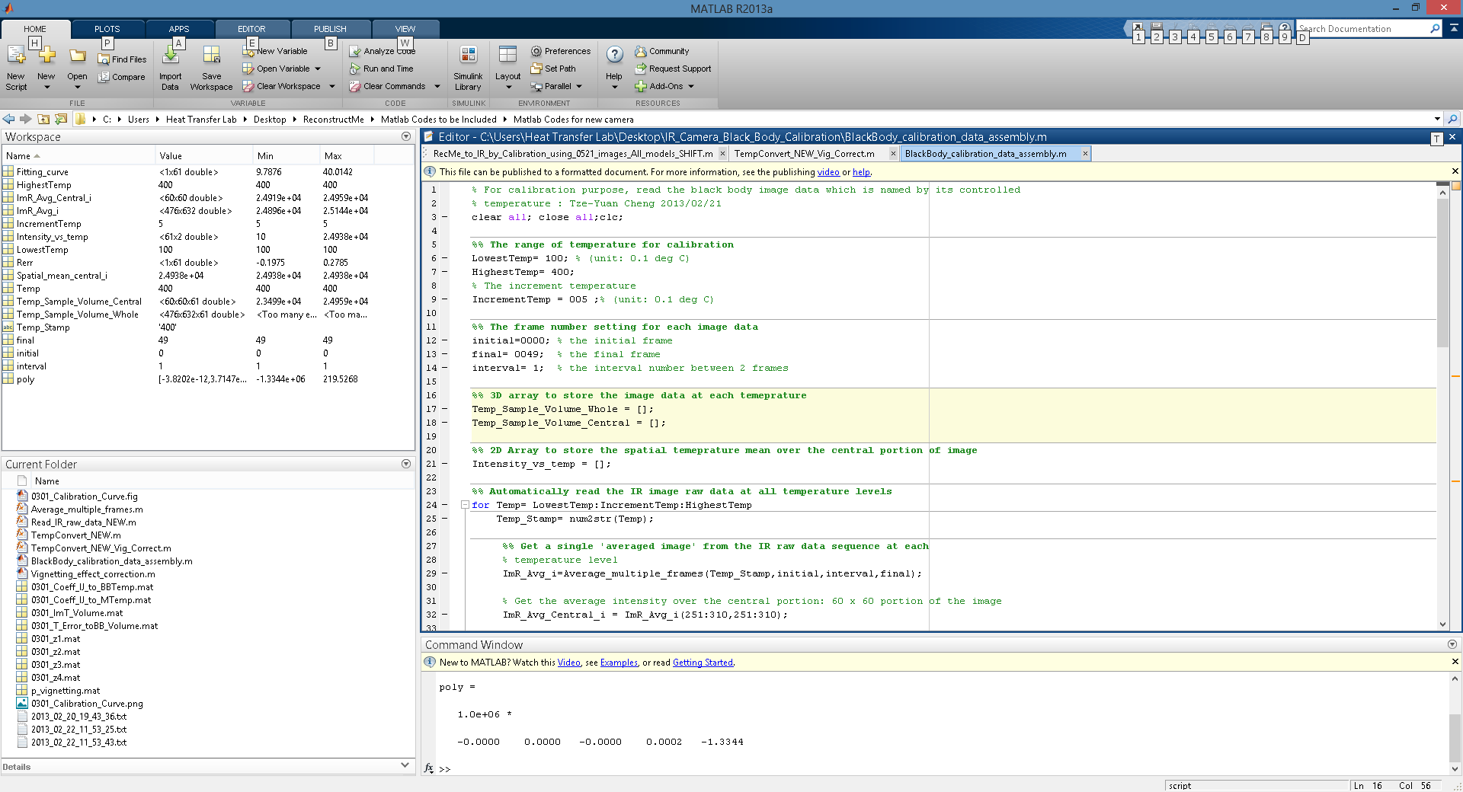

* The polynomial coefficients of the calibration will be stored in the variable:

“poly”

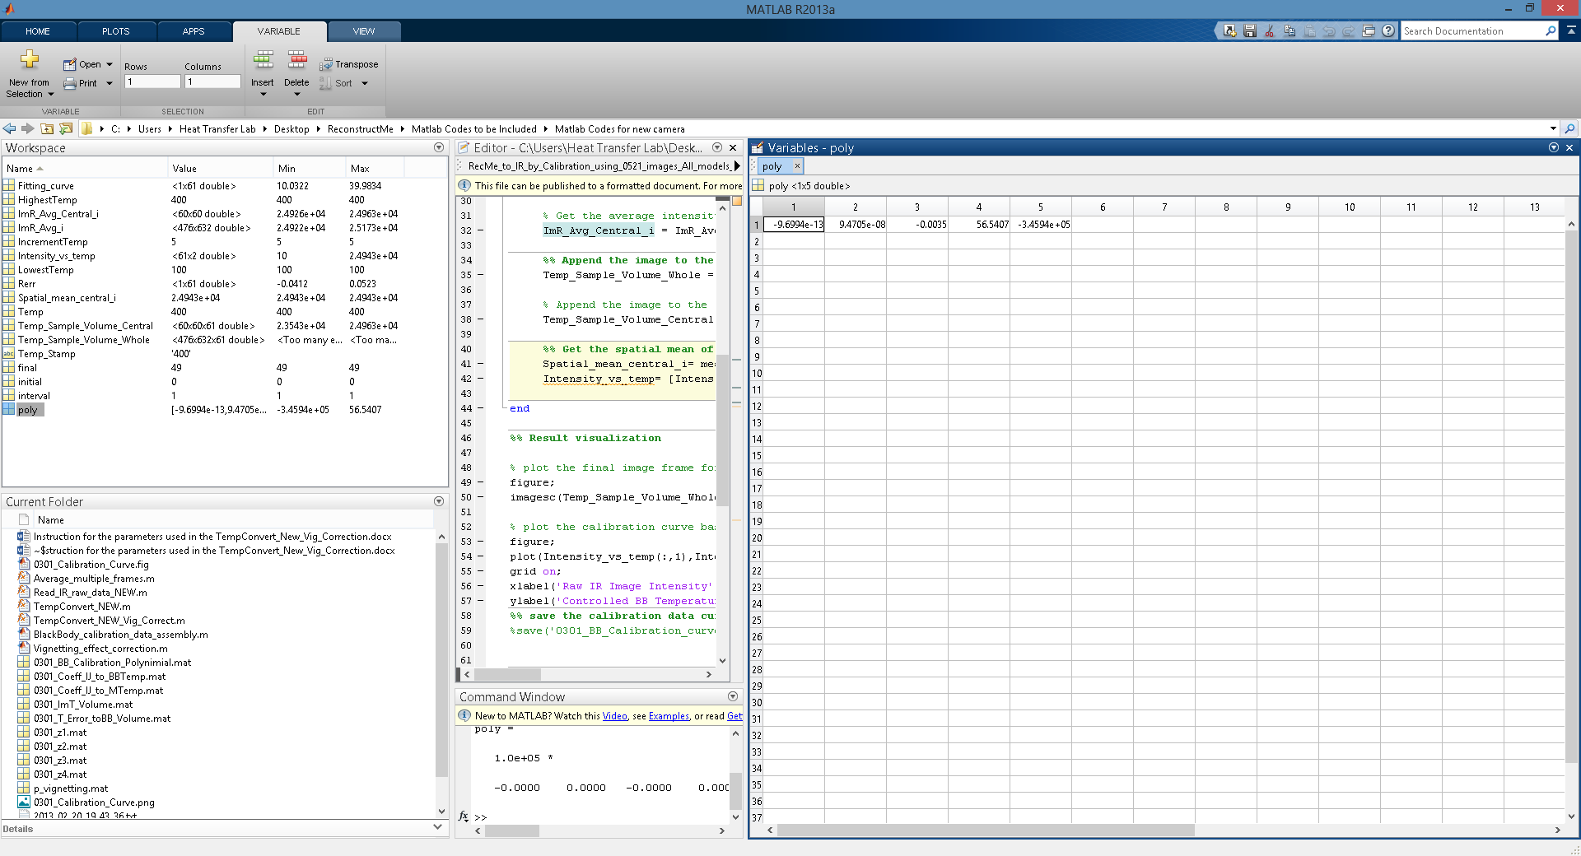

1. And the temperature calibration curve is shown as follows

